- Characters - | I Spend my Weekends..... | Most embarassing Moment | Donald Trump Should...... | Last Song you Listened to was... | Favorite Sport | Words of Wisdom
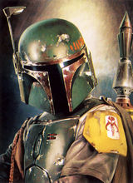  Boba Fett  Bounty Hunter | Counting my hard earned credits and cleaning my weapons,. There's lot's of blood on em. | Being knocked into the Sarlacc pit by a Blind Han Solo | Continue Deregulating hunting, Keep the free hunting. | “Run to the Hills” - By Iron Maiden | Hunting..... | “Two in the chest and one in the head”.
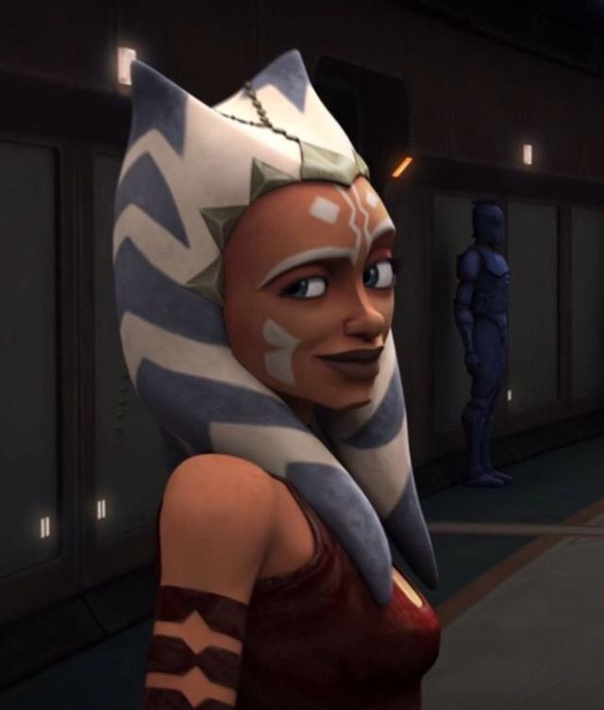  Ahsoka Tano  Jedi Knight | Relaxing, reading and catching up on TV shows I missed during the week. | Having my Lightsaber stolen by a Pickpocket. | Gracefully Resign, hold on to the reputation he has. | “Up, Up and Away” - By Kid Cudi | I can't choose a favorite, i'd say i'm a fan of them all. | “You don't have to look tough to be tough”.
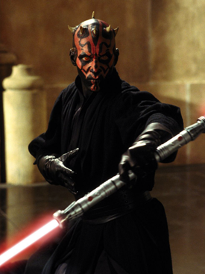  Darth Maul  Phantom Menace | Hunting Obi-Wan Kenobi. | My Brother seeing me in the worst place of my life. | Stay the Course – Hang in there Donny! | “I Stand Alone” - By Godsmack | How 'bout them Cowboys!! | “To be successful in life you need one singular vision, My Vision”.
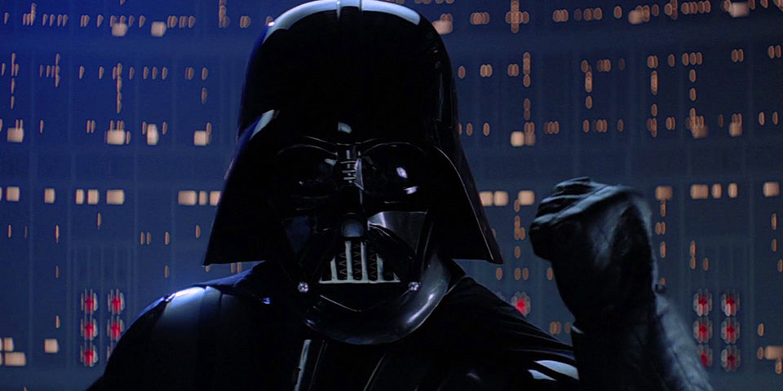  Darth Vader  Sith Lord | Every day is a work day. | Getting three of my limbs hacked off by my former Master. | Take power for himself, true power is one that derives from one self. | “The Imperial March” - By John Williams | Boxing – All fighting with the strength in the Individual | “If only you knew the Power of the Dark Side”.

